**PIZZA SALES SQL QUERIES**

**KPIs**

**1.Total Revenue**

SELECT SUM(total_price) AS Total_Revenue

FROM pizza_sales



**2.** **Average Order Value**

SELECT SUM(total_price)/COUNT(DISTINCT order_id) AS Average_Order_Value

FROM pizza_sales



**3.Total Pizza Sold**

SELECT SUM(quantity) AS Total_Pizza_Sold

FROM pizza_sales



**4.** **Total Orders Placed**

SELECT COUNT(DISTINCT order_id) AS Total_Orders

FROM pizza_sales



**5.** **Average Pizzas per order**

SELECT CAST(CAST(SUM(quantity) AS DECIMAL(10,2))/ CAST(COUNT(DISTINCT order_id) AS DECIMAL(10,2)) AS DECIMAL(10,2)) AS Average_Pizzas_per_Order

FROM pizza_sales



**INSIGHTS**

**1.** **Daily Trend for Total Orders**

SELECT DATENAME(DW , order_date) as Order_day , COUNT(DISTINCT order_id) AS Total_orders

FROM pizza_sales

GROUP BY DATENAME(DW , order_date)

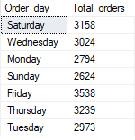

**2.** **Monthly Trend for Total Orders**

SELECT DATENAME(MONTH , order_date) as Month_Name , COUNT(DISTINCT order_id) AS Total_orders

FROM pizza_sales

GROUP BY DATENAME(MONTH , order_date)

ORDER BY Total_orders DESC

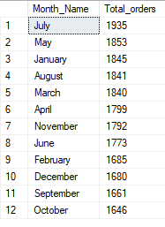

**3.** **% Sales by Pizza Category**

SELECT pizza_category,

SUM(total_price) * 100.0 / (SELECT SUM(total_price) FROM pizza_sales) AS Percentage_Sales

FROM pizza_sales

GROUP BY pizza_category;

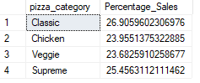

**3.** **% Sales by Pizza Size**

SELECT pizza_size, CAST(SUM(total_price) AS DECIMAL(10,2)) AS Total_Sales,

CAST(SUM(total_price) * 100.0 / (SELECT SUM(total_price) FROM pizza_sales) AS DECIMAL(10,2)) AS Percentage_Sales

FROM pizza_sales

GROUP BY pizza_size

ORDER BY Percentage_Sales DESC

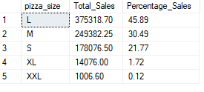

**4.Top 5 Pizza by Revenue**

SELECT TOP 5 pizza_name , SUM(total_price) AS Total_Revenue

FROM pizza_sales

GROUP BY pizza_name

ORDER BY Total_Revenue DESC

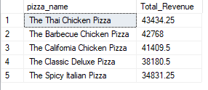

**5.Bottom 5 Pizza by Revenue**

SELECT TOP 5 pizza_name , SUM(total_price) AS Total_Revenue

FROM pizza_sales

GROUP BY pizza_name

ORDER BY Total_Revenue

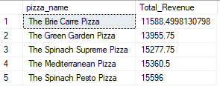

**6.Top 5 Pizza by Quantity**

SELECT TOP 5 pizza_name , SUM(quantity) AS Total_Revenue

FROM pizza_sales

GROUP BY pizza_name

ORDER BY Total_Revenue DESC

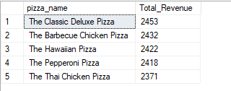

**7.Bottom 5 Pizza by Quantity**

SELECT TOP 5 pizza_name , SUM(quantity) AS Total_Revenue

FROM pizza_sales

GROUP BY pizza_name

ORDER BY Total_Revenue

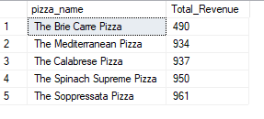

**8.Top 5 Pizza by Orders**

SELECT TOP 5 pizza_name , COUNT(DISTINCT order_id) AS Total_Orders

FROM pizza_sales

GROUP BY pizza_name

ORDER BY Total_Orders DESC

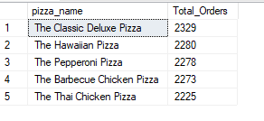

**9.Bottom 5 Pizza by Orders**

SELECT TOP 5 pizza_name , COUNT(DISTINCT order_id) AS Total_Orders

FROM pizza_sales

GROUP BY pizza_name

ORDER BY Total_Orders

